**For Pipes Speed and speed up after a. certain score:**

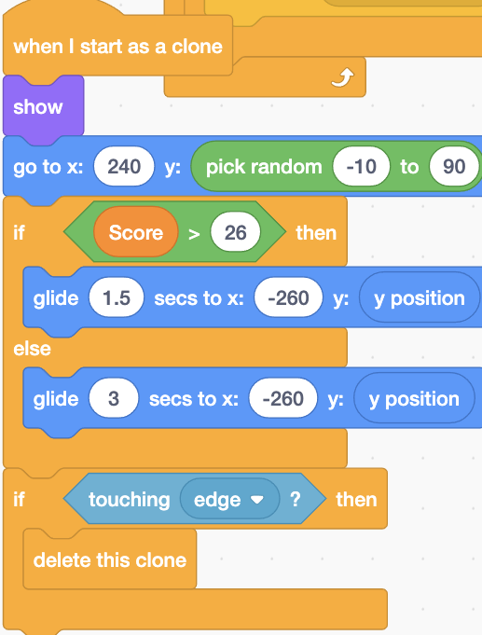

Here we use If-then-else statement to normally glide with 3s margin and if score increases from 26 then it speeds up twice.

* To stop clones to collect at the end use delete this clone if. Touching edge.

**For Creating High score:**

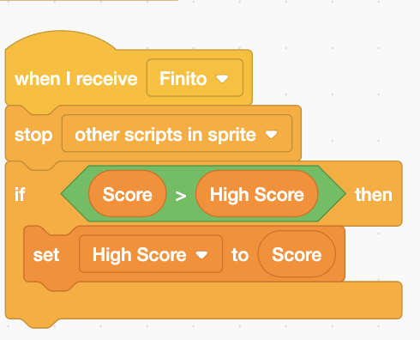

When we die we should use a broadcasting mechanism and when we receive that message

(finito in this case) then if score is greater than high score. Then high score variable will be converted to score.

**For animations of bird we should add more costumes of the bird:**

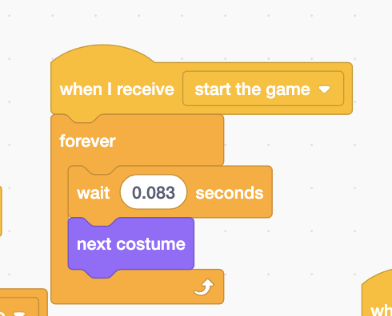

This code allows us to change costume after each 0.083 interval this will help us in creating a smooth animation

**Gameover broadcast:**

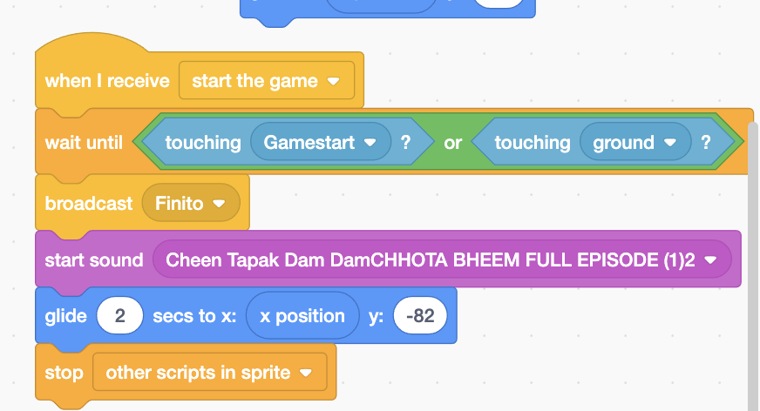

When the bird touches pipes(gamestart in this case) or ground it will broadcast a message (finito in this case) and allow the bird to fall to the ground and then stop all other scripts

**Gameover sprite:**

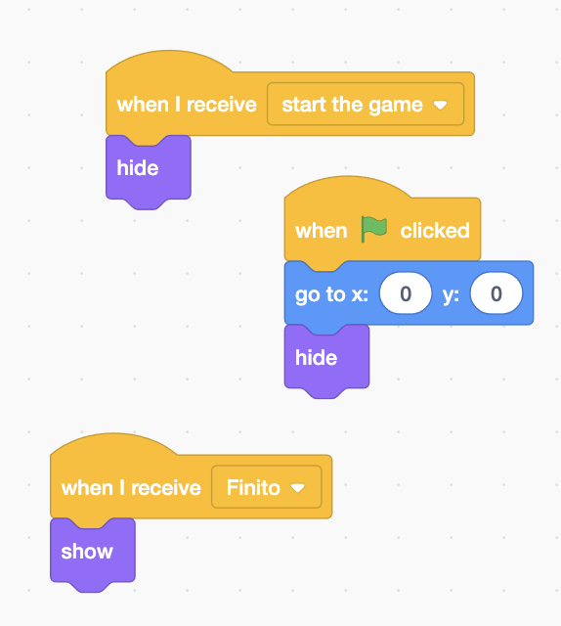

Here we have created a gameover sprite and linked it to receiving messages . when we receive Start the game it hides. And when we receive Finito it shows. 

**For play button sprite:**

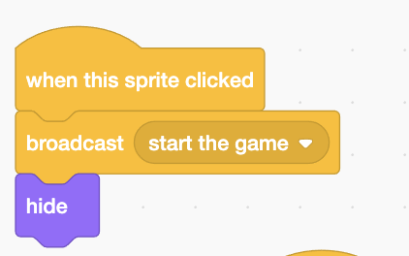

When this play button sprite is clicked it will broadcasta start the game message that will actsimillar to a “when flag clicked” button .

* For smoother animations on hovering we can use

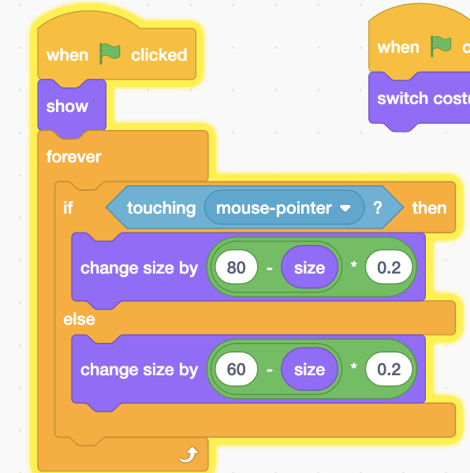

Here On pointing of mouse pointer will increase the size of Sprite

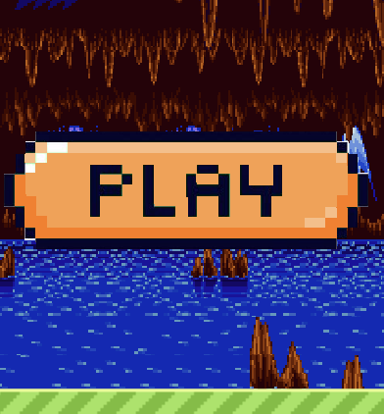

**Instructions sprite:**

To help the player identify the instructions of the game we give Instruction sprite here we use multiple costumes of varying opacity.

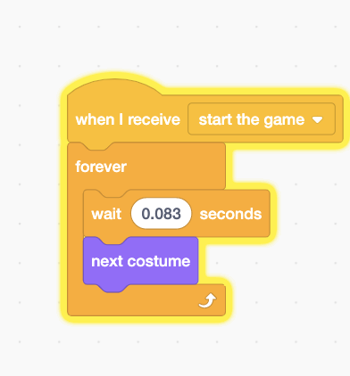

**This code is [1]used for giving animations.**

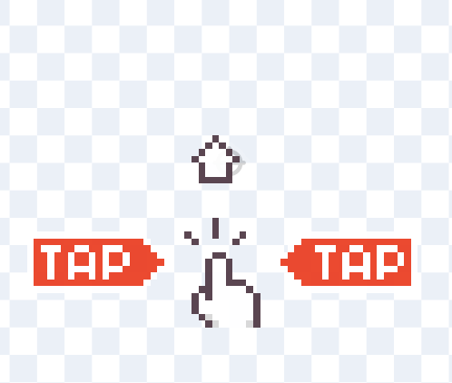

Like theses

1. Made by Sarmad Durrani